PROGRAM 1:

**public** **class** Box {

**double** h,w,d;

Box(**double** width,**double** height,**double** depth)

{

h=height;

w=width;

d=depth;

}

**double** volume()

{ **double** v;

v=h*w*d;

**return** v;

}

**public** **static** **void** main(String[] args) {

Box bc = **new** Box(9.8,80.3,10.7);

System.***out***.println("Volume of box is " +bc.volume());

}

}

OUTPUT:

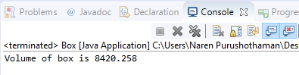

PROGRAM 2:

**public** **class** PowerCalci {

**public** **static** **void** main(String[] args) {

// **TODO** Auto-generated method stub

System.***out***.println(Calculator.*powerDouble*(85.0,2));

System.***out***.println(Calculator.*powerInt*(85,3));

}

}

**class** Calculator

{

**static** **double** powerInt(**int** num1, **int** num2)

{

**return** Math.*pow*(num1, num2);

}

**static** **double** powerDouble(**double** num1, **double** num2)

{

**return** Math.*pow*(num1, num2);

}

}

OUTPUT:

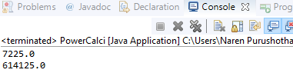

PROGRAM 3:

**class** Patient{

String name;

**double** height,weight;

Patient(**double** w,**double** h)

{

weight = w;

height = h;

}

**double** BMI()

{

**return**((weight/(height*height))*703);

}

}

**class** Patients

{

**public** **static** **void** main(String[] args) {

Patient p = **new** Patient(75,156);

System.***out***.println("The BMI : "+p.BMI());

}

}

OUTPUT:

